**TECHNICAL TEAM**

1. **Lanre Salako - Head, Product Development & Design**

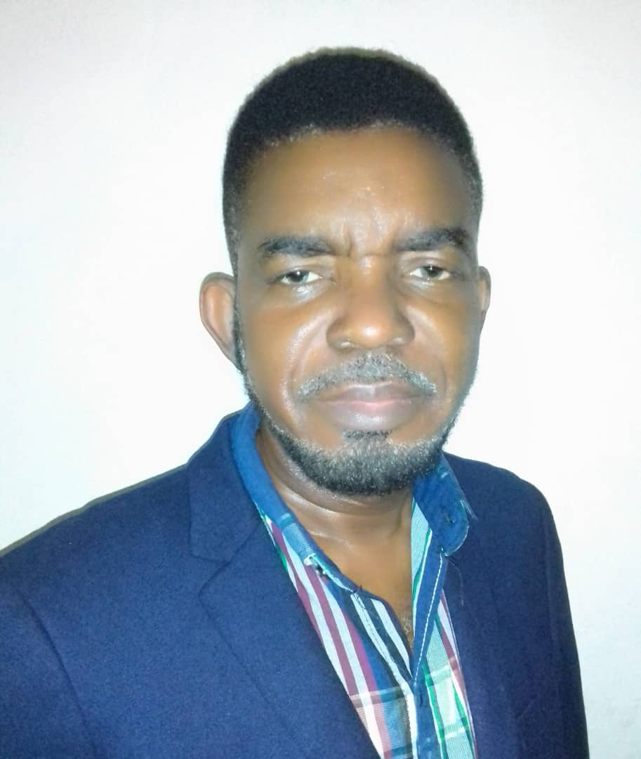With over 27 years of professional experience, he has been a key player in Nigeria's Infrastructural Development Industry, specializing in Strategic Project Development, Design & Implementation.

He pioneered Computer Aided Drafting & Design, training professionals and managing projects across various sectors like Mechanical & Electrical Services, IT systems, Renewable Energy, Geographic Information Systems & Project Management. Holding an HND in Mechanical Engineering from Yaba College of Technology, he has further elevated his expertise through industry-focused programs. Proficient in AutoCAD, MicroStation, Civil 3D, and Revit, he has also facilitated tailored product development for TNL's African market needs.

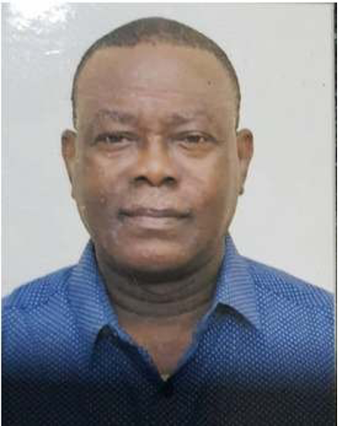

1. **Brig Gen Abayomi Salako Rtd - LithTech Rep & Site Design Consultant**

Salako boasts a diverse educational journey from institutions like Adrao International School, Birch Freeman High School, Federal School of Arts & Science, Nigerian Defense Academy, and University of Ibadan. His career spans remarkable roles:

* Engaged in bridge construction in North West & North East.
* Commanded Ikeja Bomb blast efforts from 2002 to 2005.
* Held positions including Staff Officer, Commanding Officer at Nigerian Army School of Military Engineering, and Chief Instructor at Combat Engineering Wing.
* Served as Chief of Staff at HQ Nigeria Army Engineers and Commander Engineer Brigade.

He holds memberships in professional bodies like IAEM and IABTI, and earned degrees including Civil Engineering Diploma, Construction Management Diploma, Bachelors in Mathematics, and a Masters in Strategic Studies from the University of Ibadan. His honors encompass MEOD, GSS, Psc, Field Command Medal, and Chief of Army Staff Medal for his role in clearing the Ikeja Bomb Blast in 2002.

1. **Adebayo Salako - Head, Installation and Maintenance**

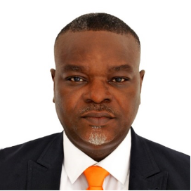With an extensive 20-year background in Nigeria's Power Sector, this professional's journey began with the first IPP in Nigeria, initially owned by Enron and later by AES Global Energy Company. Holding a COREN Registered Engineer status, they hold a Postgraduate Degree (PGD) in Electrical Power Systems from the Federal University of Technology Akure.

Their educational accomplishments include Leadership Training from the Darden Executive Program at the University of Virginia, USA, as well as a Higher National Diploma (HND) in Electrical Electronics Engineering from Yaba College of Technology. They've also earned certifications as a Heat Rate Expert from DPL Generation Center, Ohio, USA, and in Reliability Centered Maintenance (RCM) from MERIDIUM. Currently pursuing an MBA in Business Administration at the University of Zambia through the UniCaf University Program.

At Transcorp Power, they served as CTO, overseeing the successful implementation of a CMMS, comprehensive O&M programs, life cycle planning, and specialized training. During their tenure at Azura-Edo Power Plant as Maintenance Manager for PIC (Marubeni Group), they achieved outstanding feats including setting up a warehouse from scratch, assembling a proficient maintenance team, and achieving an impressive 98% plant availability in 2018.

Working with AES, they contributed significantly, such as reducing downtime by expertly repairing a 40MVA Transformer, aiding in ISO and OHSAS certifications, facilitating black starting of the grid through Egbin Power Plant, and enhancing the Power Plant's role in ancillary services for the Grid.

1. **Muka Muodozie – Project Manager**



Muka is a dynamic professional with an entrepreneurial mindset and extensive management experience spanning various industries. With over 5 years of proven expertise, she holds the esteemed title of a certified Project Management Professional (PMP). This qualification underlines her mastery in project management methodologies and best practices.

Currently, Muka adeptly balances her role as a project manager at TNL while actively managing and nurturing a diverse portfolio of business ventures. Her comprehensive experience equips her to oversee projects with a strategic vision, ensuring their successful execution from inception to completion.

Muka's academic foundation includes a degree in computer science from Bowen University, which underscores her technical prowess and ability to leverage innovative technologies to streamline project workflows. Her unique blend of technical knowledge and management acumen empowers her to drive projects that seamlessly integrate cutting-edge solutions.